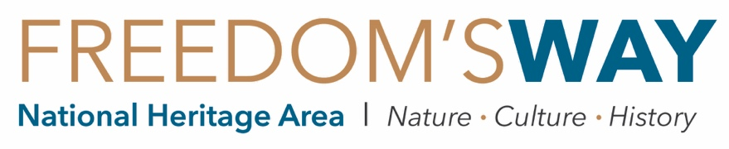

HIDDEN TREASURES STIPEND REQUEST FORM

Freedom’s Way offers our Hidden Treasures partners the opportunity to receive a stipend of up to $250 to reimburse qualified program-related expenses, as documented by receipts, paid invoices, etc. Qualified expenses include materials, supplies, or other costs associated with the specific program being offered through Hidden Treasures. Partners must submit an In-Kind Donation Form to be eligible to receive a stipend.
The costs of travel, staff time, capital expenditures, food and beverages are not eligible for reimbursement. Stipends will only be issued to organizations or public entities. Limit one stipend per partner, and one stipend per program.
If your expenses exceed $250, please consider making an in-kind donation of the remaining value to Freedom’s Way—it’s as simple as filling out the In-Kind Donation of Goods/Venue/Cash Form! Freedom’s Way relies on in-kind donations from our partners to secure the dollar-for-dollar match required for the federal funding we receive from the National Park Service. Thank you!
Please submit this form and backup documentation such as receipts, paid invoices, etc. to DHamelin@FreedomsWay.org, or mail to 94 Jackson Road, Ste. 311, Devens, MA 01434.
DUE FRIDAY, JUNE 14, 2019!

Name of Hidden Treasures program: | ________________________________________________________________
Organization to make check out to: | ________________________________________________________________
Address to mail check to: | ________________________________________________________________
 | ________________________________________________________________
Person to mail check in care of: | ________________________________________________________________

Date | Description of Expense |  | Value | Qty. | Total Value
1/1 | EXAMPLE – Binoculars |  | $25 | 4 | $100
1/1 | EXAMPLE – Speaker fee for presentation |  |  |  | $150
 |  | TOTAL: |  |  | $

QUESTIONS? Please call us at (978) 772-3654!

