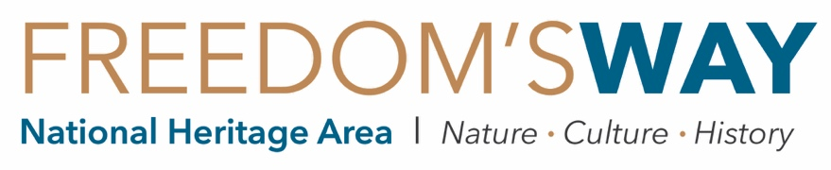

IN-KIND DONATION OF GOODS/VENUE/CASH FORM

Freedom’s Way relies on in-kind donations from volunteers like you to secure the dollar-for-dollar match it is required to provide for the federal funding it receives from the National Park Service. Please use this form to document the value of in-kind donations for the following:

- Goods – The value of supplies purchased for a program, such as printed brochures, binoculars for birding, etc.
- Venue – The fair market value of the space used to hold a program, e.g. the hall typically costs $100 to rent. If no invoice is available as documentation, a donation letter will be sufficient.
- Cash – The amount paid for a program-related item, such as a speaker fee of $250.
Please submit this form and backup documentation such as receipts, paid invoices, or donation letters to DHamelin@FreedomsWay.org, or mail to 94 Jackson Road, Ste. 311, Devens, MA 01434. Your contribution allows Freedom’s Way to continuing working with local community partners. Thank you!

Name: | Organization:
Email: | Address:
FW Program/Project:
Signature: | Date:

Date | Description of Goods/Venue/Cash Donated |  | Value | Qty. | Total Value
1/1 | EXAMPLE - Binoculars |  | $25 | 10 | $250
1/1 | EXAMPLE – Speaker fee for presentation |  |  |  | $300
 |  | TOTAL: |  |  | $

QUESTIONS? Please call us at (978) 772-3654!

