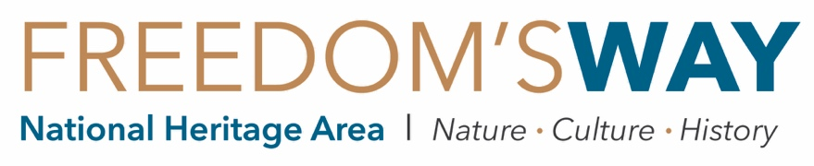

IN-KIND DONATION OF SERVICES FORM

Freedom’s Way relies on in-kind donations from volunteers like you to secure the dollar-for-dollar match it is required to provide for the federal funding it receives from the National Park Service. In-kind donations of services may include:
- the fair market value of time contributed by a volunteer;
- the professional value of hours contributed by a person on another organization’s non-federal payroll; or,
- the professional value of hours contributed by a volunteer for a specific professional service.
The value of miles driven for tasks related to a program or project may also be contributed as an in-kind donation.
The time you dedicate to a program or project related to Freedom’s Way is valuable. Please keep track of this information below and submit it to DHamelin@FreedomsWay.org, or mail to 94 Jackson Road, Ste. 311, Devens, MA 01434. Your contribution allows Freedom’s Way to continuing working with local community partners. Thank you!

Name: | Organization:
Email: | Address:
FW Program/Project:
Signature: | Date:

Date | Description of Services Provided | Rate Type* | Hrly Rate | # of Hrs | Hrs x Rate | Miles
 |  |  | TOTAL: |  | $

*Rate Type: ‘PR’ = Professional Rate, ‘VR’ = Volunteer Rate
PR = Hourly rate set by donor for providing a specific professional service, or volunteering in their professional capacity.
VR = $31.17 is the value of one volunteer hour in Massachusetts in 2017, according to IndependentSector.org.
The IRS’s standard mileage rate per mile driven in service of a charitable organization in 2019 is $0.14.

QUESTIONS? Please call us at (978) 772-3654!

